INTERNAL AND INTERNET FACING LOAD BALANCER

ARCHITECTURE
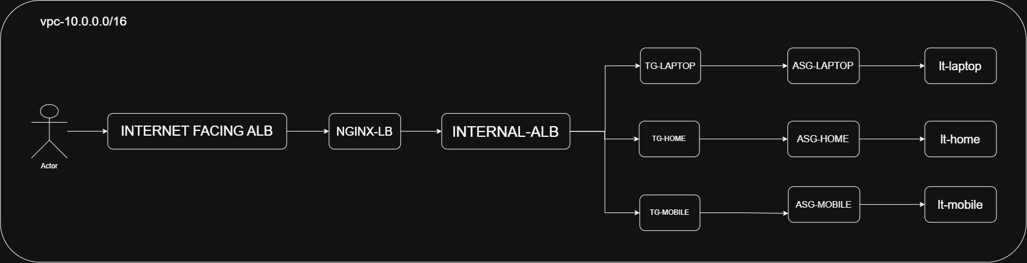

PHASE-1 (creation of vpc)
- create a vpc (10.0.0.0/16)
- create a subnets
- public-subnet-1 – (10.0.1.0/24) – (az-1a)
- public-subnet-2 – (10.0.2.0/24) – (az-1b)
- private-subnet-1 – (10.0.11.0/24) – (az-1a)
- private-subnet-2 – (10.0.12.0/24) – (az-1b)
- create a internet gateway and attach to a vpc
- create a nat gateway in public-subnet-1
- create a route table
- public-rt
- associate all public subnets
- add internet gateway to routes
2. private-rt
- associate all private subnets
- add nat gateway to routes
- Edit DNS hostname of vpc
- click on vpc
- click on actions
- edit vpc settings
- enable dns hostnames
- save

PHASE-2 (creation of security groups)
- SG-INTERNET-ALB
- Allow http -> 0.0.0.0/0
- Allow https -> 0.0.0.0/0

2. SG-NGINX
- Allow http -> SG-INTERNET-ALB
3. SG-INTERNAL-ALB
  - Allow 8001 -> SG-NGINX
  - Allow 8002 -> SG-NGINX
  - Allow 8003 -> SG-NGINX
4. SG-APPLICATION
- Allow 8001 -> SG-INTERNAL-ALB
- Allow 8002 -> SG-INTERNAL-ALB
- Allow 8003 -> SG-INTERNAL-ALB
PHASE-3 (creation of launch template)
- LT-HOME
- name – (LT-HOME)
- ami – (amazon linux)
- instance_type – t3.micro
- sg - SG-APPLICATION
- user_data
#!/bin/bash
dnf update -y
dnf install httpd -y
sed -i 's/^Listen 80$/Listen 8001/' /etc/httpd/conf/httpd.conf
systemctl enable httpd
systemctl start httpd
echo "<h1>Home instance $HOSTNAME</h1>" > /var/www/html/index.html
systemctl restart httpd

- LT-MOBILE
- name – (LT-MOBILE)
- ami – (amazon linux)
- instance_type – t3.micro
- sg - SG-APPLICATION
- user_data
#!/bin/bash
dnf update -y
dnf install httpd -y
sed -i 's/^Listen 80$/Listen 8002/' /etc/httpd/conf/httpd.conf
systemctl enable httpd
systemctl start httpd
mkdir -p /var/www/html/mobile
echo "<h1>Mobile instance $HOSTNAME</h1>" > /var/www/html/mobile/index.html
systemctl restart httpd

- LT-LAPTOP
- name – (LT-LAPTOP)
- ami – (amazon linux)
- instance_type – t3.micro
- sg - SG-APPLICATION
- user_data
#!/bin/bash
dnf update -y
dnf install httpd -y
sed -i 's/^Listen 80$/Listen 8003/' /etc/httpd/conf/httpd.conf
systemctl enable httpd
systemctl start httpd
mkdir -p /var/www/html/laptop
echo "<h1>Laptop instance $HOSTNAME</h1>" > /var/www/html/laptop/index.html
systemctl restart httpd

PHASE-4 (creation of autoscaling group)
ASG-HOME
- Name – ASG-HOME
- Launch template – LT-HOME
- Vpc – my-vpc
- Subnets – private-subnet-1/private-subnet-2
- Desired capacity – 1
- Minimum capacity – 1
- Maximum capacity – 4
- Enable health check - EC2 health check

ASG-MOBILE
- Name – ASG-MOBILE
- Launch template – LT-MOBILE
- Vpc – my-vpc
- Subnets – private-subnet-1/private-subnet-2
- Desired capacity – 1
- Minimum capacity – 1
- Maximum capacity – 4
- Enable health check - EC2 health check

ASG-LAPTOP
- Name – ASG-LAPTOP
- Launch template – LT-LAPTOP
- Vpc – my-vpc
- Subnets – private-subnet-1/private-subnet-2
- Desired capacity – 1
- Minimum capacity – 1
- Maximum capacity – 4
- Enable health check - EC2 health check

PHASE-5 (creation of target groups)
TG-HOME
- Target type – Instance
- Tg name – TG-HOME
- Vpc – my-vpc
- Port – 8001
- Protocol – http
- Health check path - /
- Create a target group
TG-MOBILE
- Target type – Instance
- Tg name – TG-MOBILE
- Vpc – my-vpc
- Port – 8002
- Protocol – http
- Health check path - /mobile/
- Create a target group
TG-LAPTOP
- Target type – Instance
- Tg name – TG-LAPTOP
- Vpc – my-vpc
- Port – 8003
- Protocol – http
- Health check path - /laptop/
- Create a target group

PHASE-6 (internal application load balancer)
- name – INTERNAL -ALB
- lb type – application load balancer
- scheme – internal
- vpc – my-vpc
- subnets – private-subnet-1/private-subnet-2
- sg - SG-INTERNAL-ALB
- listener – port (8001) – forward to tg (TG-HOME)
- listener – port (8002) – forward to tg (TG-MOBILE)
- listener – port (8003) – forward to tg (TG-LAPTOP)

PHASE-7 (creation of nginx-launch-template)
LT-NGINX
- name – (LT-NGINX)
- ami – (amazon linux)
- instance_type – t3.micro
- sg - SG-NGINX
- user_data
#!/bin/bash
dnf update -y
dnf install nginx -y
cat > /etc/nginx/conf.d/app.conf <<'EOF'
server {
listen 80;
location / {
proxy_pass http://internal-INTERNAL-ALB-1626036581.ap-south-1.elb.amazonaws.com:8001;
proxy_set_header Host $host;
proxy_set_header X-Real-IP $remote_addr;
proxy_set_header X-Forwarded-For $proxy_add_x_forwarded_for;
}
location /mobile/ {
proxy_pass http://internal-INTERNAL-ALB-1626036581.ap-south-1.elb.amazonaws.com:8002;
proxy_set_header Host $host;
proxy_set_header X-Real-IP $remote_addr;
proxy_set_header X-Forwarded-For $proxy_add_x_forwarded_for;
}

location /laptop/ {
proxy_pass http://internal-INTERNAL-ALB-1626036581.ap-south-1.elb.amazonaws.com:8003;
proxy_set_header Host $host;
proxy_set_header X-Real-IP $remote_addr;
proxy_set_header X-Forwarded-For $proxy_add_x_forwarded_for;
}

}
EOF
nginx -t
systemctl enable nginx
systemctl start nginx

PHASE-8 (creation of nginx-autoscaling-group)
ASG-NGINX
- Name – ASG-NGINX
- Launch template – LT-NGINX
- Vpc – my-vpc
- Subnets – private-subnet-1/private-subnet-2
- Desired capacity – 1
- Minimum capacity – 1
- Maximum capacity – 4
- Enable health check - EC2 health check

PHASE-9 (creation of nginx-target-group)
TG-NGINX
- Target type – Instance
- Tg name – TG-NGINX
- Vpc – my-vpc
- Port – 80
- Protocol – http
- Health check path - /
- Create a target group
Attach these target group to autoscaling group
ASG-NGINX → Integrations → Load balancing → TG → TG-NGINX

PHASE-10 (creation of internet-facing-LB)
- name – INTERNET-FACING-ALB
- lb type – application load balancer
- scheme – internet-facing
- vpc – my-vpc
- subnets – public-subnet-1/public-subnet-2
- sg - SG-INTERNET-ALB
- listener – port (80) – forward to tg (TG-NGINX)
- create a target group

